**Reading Counts! Quizzes**

To find out if a fiction or nonfiction book has a Reading Counts! Quiz available, families can Google Search: HMH Reading Counts Book Expert.

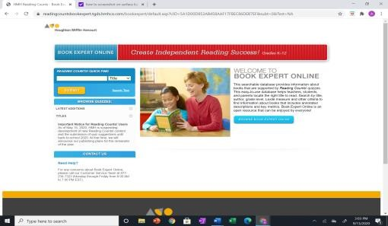

There are Reading Counts! Quizzes for all major book publishers (not just Scholastic). Typically Reading Counts Quizzes are available 2-3 months after a book has been published.

Please email Katie Griffith if your student read a book(s) that don’t have a quiz. Points will be added to your total based on the book that was read.

**Reading Counts! READING OLYMPICS**

Students can access Reading Counts! quizzes by logging into Clever and clicking on the Reading Counts icon.

Students can take quizzes Monday through Friday from 6:30am-3:30pm. Quizzes are available on weekdays when school is not in session.

A 70% or higher is passing on the 10 question Reading Counts! Quiz. If students don’t pass the book quiz, they can take a quiz up to three times, with 24 hours between each attempt.

Since most Reading Counts quizzes have a bank of 30 questions, students are likely to see different quiz questions on a second or third quiz attempt.

*

Watching movies without reading the

book and taking quizzes is

not permitted

.

After nonfiction books are read in their entirety, students are encouraged to use the book for nonfiction quizzes to develop research skills

Students should not refer to the book when taking a quiz for fiction books.

Quizzes may be taken if a student has listened to the unabridged audio version of a book or had a teacher or parent read the book aloud.

|  |  |  |
| --- | --- | --- |
| **How do students earn a Reading** | | |
| **Olympics Gold Medal in 3rd-5th** | |  |
| **Grade?** |  |

**3rd Grade-80** Reading Counts! points earned this school year.

**4th Grade-110** Reading Counts! points earned this school year.

**5th Grade-130** Reading Counts! points earned this school year.

If the Reading Counts! Gold Medal points are not appropriate for your student, please communicate with your student’s teacher to determine what number of Reading Counts! points you believe would be appropriate.

Gold medals will be awarded at the Thursday flag salute to those that earned a medal on December 14, March 21, and May 16 (progress will be checked the week prior).

|  |  |
| --- | --- |
| **May 7, 2024 is the last day to** | |
| **qualify for a gold medal.** |  |

Contact Katie Griffith, katiengriffith@hotmail.com for Reading Olympics support.

PTA Sponsored.